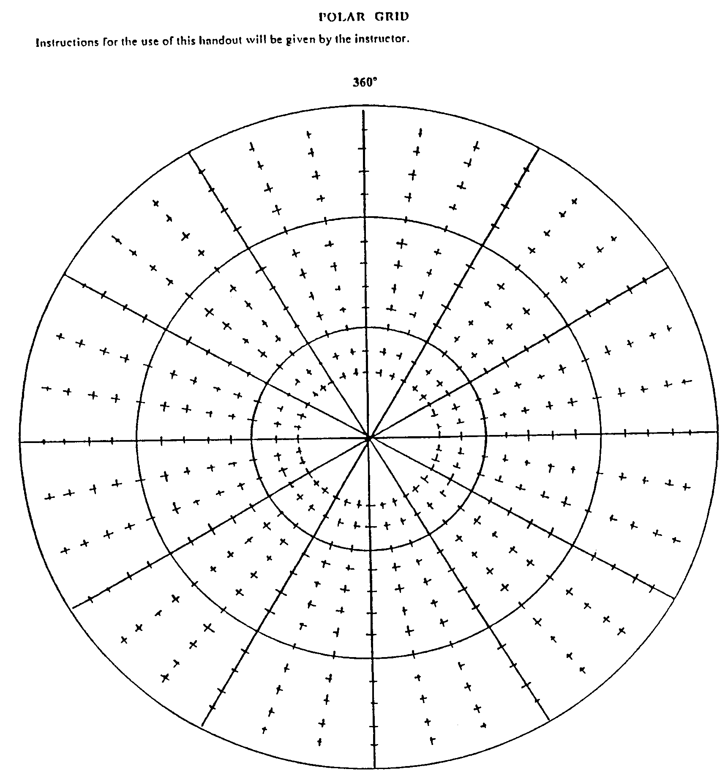
6
5
4
2
3
1
6
5
4
1
2
3
Determine Bearing and Range Coordinates for the marked positions.
1. zero one zero, range fifty
2. zero four zero, range ninety
3. one zero zero, range one hundred forty
4. one eight zero, range seventy
5. two five zero, range one hundred twenty
6. three two zero, range one hundred ten
Plot the following Lat/Long Position. Ensure you label you plots with the corresponding number.
1. two two zero, range thirty
2. one zero zero, range fifty
3. zero five zero, range one hundred thirty
4. one two zero, range one hundred twenty
5. three one zero, range sixty
6. one one zero, range eighty

